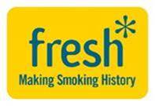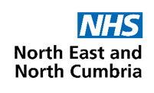

**DECLARATION FOR A SMOKEFREE FUTURE**

***“Smoking has a negative impact on our region’s health, wealth, happiness and wider economy.***

***The region has suffered for too many years from the harms of tobacco smoking with thousands of local people prematurely dying from avoidable smoking related illnesses driven by global tobacco companies with a pursuit for profit.***

***We believe it is unacceptable that at least one in every two long term smokers will die from smoking and for each person who dies, there are 30 people suffering from a smoking related illness. It is wrong that tobacco related harm is costing our region around £1.99 billion each year due to the impact on health care, social care, fires and our businesses.***

***Our public agree with us. They don’t want this to continue happening.***

***We have ensured that reducing smoking rates has been a key priority for both local government and the NHS over many years and with the support from Fresh our dedicated regional tobacco control programme we are proud that our region has achieved the biggest overall drop in adult smoking rates since 2005.***

***We however recognise that there is much more to be done and continued system wide efforts and focus must be given to reducing smoking across all groups noting that higher smoking prevalence is associated with almost every indicator of deprivation or marginalisation.***

***We commit that we will strive to achieve our regional ambition to reduce overall rates to 5% or less by 2030 but ultimately we believe that to achieve our Better Health and Wellbeing For All Plan we need to be bold and ambitious.***

***Our final aim is that tobacco smoking will and should become obsolete- a thing of the past- and with no future generations taking it up. This will require our region advocating for effective national action that supports our regional and local focus. We know we have the support from the public who do not want any future generation to suffer from tobacco related harm.***

***A smokefree future, free of the death and disease from tobacco, is needed, wanted and workable. This would improve the health and wealth of our region’s most disadvantaged communities more than any other measure”.***

***27th September 2023 (updated Feb 2025 with latest estimates for cost of smoking)***